In-Situ Timed Procedure Training

1-Google Form
Log in to Google Drive
Click on the Google Sheet icon
Click on Create a new Sheet

Question | Title | Type | Obligatory
1 | Procedure | Multiple choice (circles) | Yes
2 | Performer | Short answer | Yes
3 | Observer | Short answer | Yes
4 | Found all equipment? | Multiple choice Yes/No | Yes
5 | Carried out all steps? | Multiple choice Yes/No | Yes
6 | Time (min:sec) | Short answer | No
7 | Comments | Short answer | No

2-URL to Google Form
1-Click on Share (the icon with the person and the + sign)
2-Select General Access for those answering
3-Click on Publish
4-Click on Copy Answer link
5-Paste this ULR below to use to create QR-code (example below)

https://docs.google.com/forms/d/e/1FAIpQLSfrcwCTOSAqWm8fhGVzkOXdWChf3IbulVuTuVBZaV0TAqMD6g/viewform?usp=sharing&ouid=103243276085131292328

3-URL to Google Sheet
You get the URL to the Google Sheet (to see the results) by:
1-Login into Google Drive
2-Click on your Google Form
3-Click on Share (the icon with the person and the + sign)
4-Click on General Access
5-Selecting "All with link"
6-Click on Copy Link
7-Paste this ULR below to use to create QR-code (example below)

https://docs.google.com/spreadsheets/d/1lHJCiVWeMy-yUiMeCjyBM7cWDrV5qYGXmkSUq-WvVLQ/edit?usp=sharing

4-Make QR-codes
You can ask ChatGPT to create a QR code. On Mac, you can double click on the application "Shortcuts" and get it to generate a QR code.

5-Display QR-codes
Replace the QR-codes in the page below, print out the page in A3 size, laminate it and affix to wall in your resuscitation room.
Procedure Training In-Situ

Register your training | Check registered trainings
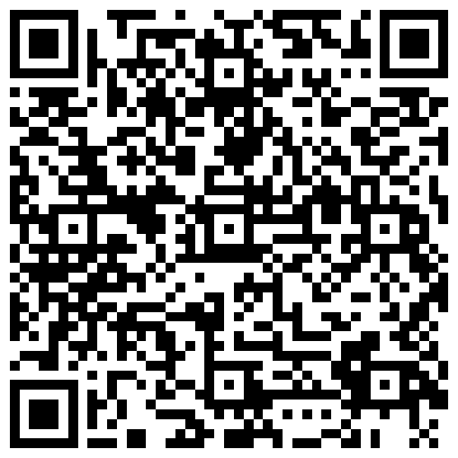 | 